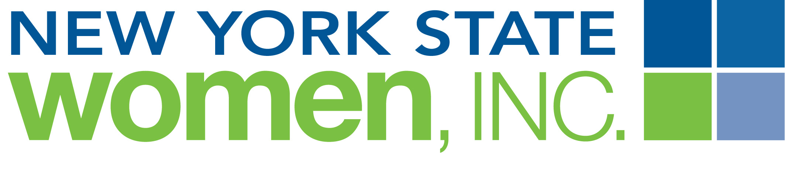
ADVERTISMENT FORM
Insert venue’s name and address; date of meeting

It is estimated that more than 100 New York State Women, Inc. members from all areas of New York State will be attending the Meeting held in to celebrate the development of their personal, professional and political skills. These women represent members from around New York State.
We invite you to join our sponsorship family – businesses, groups and individuals can support our efforts with ads and/or boosters in our Board Book.. The Book, used as a networking tool, recognizes businesses where our members live and work, where our state meetings are held and where our local organizations are part of the community. Our members strongly believe in supporting our sponsors and patrons.

Category: Rate
Business Card Boosters (approximately 2 in. high x 3.5 in wide)* $25
One Quarter (1/4) Page Ad (approximately 4.25 in. high x 3.25 in wide)* $50
One Half (1/2) Page Ad (approximately 4.5 in. high x 7.5 in. wide)* $75
Full Page Ad (approximately 10 in. high x 7.5 in. wide):* $100

* If camera ready art or jpeg is unavailable, the committee will design an ad for you; however, final approval
by you will only occur if time is available prior to publication

DEADLINE: forms and payment must be received on or before insert date

Amount Enclosed: $ Ad Category:

Advertiser Name (if different from Contact Name):
Contact Name:
Mailing Address:
Phone: ( ) Email Address:

 “Camera ready” artwork is not available; please design an ad using the following information:

Make checks payable to: NYS Women, Inc. [Indicate “insert event name” on the Memo line]
Mail completed form/artwork and checks to: Insert Name
Insert Address
Address

Questions should be directed to: Insert Name, phone and email

